Final Keyword In Java

1. [Final variable](https://www.javatpoint.com/final-keyword#finalv)
2. [Final method](https://www.javatpoint.com/final-keyword#finalm)
3. [Final class](https://www.javatpoint.com/final-keyword#finalc)
4. [Is final method inherited ?](https://www.javatpoint.com/final-keyword#finalisinherited)
5. [Blank final variable](https://www.javatpoint.com/final-keyword#finalblank)
6. [Static blank final variable](https://www.javatpoint.com/final-keyword#finalstaticblank)
7. [Final parameter](https://www.javatpoint.com/final-keyword#finalpara)
8. [Can you declare a final constructor](https://www.javatpoint.com/final-keyword#finalcons)

The **final keyword** in java is used to restrict the user. The java final keyword can be used in many context. Final can be:

1. variable
2. method
3. class

The final keyword can be applied with the variables, a final variable that have no value it is called blank final variable or uninitialized final variable. It can be initialized in the constructor only. The blank final variable can be static also which will be initialized in the static block only. We will have detailed learning of these. Let's first learn the basics of final keyword.

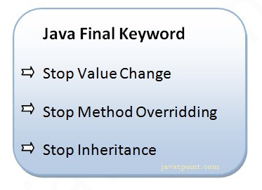

1) Java final variable

If you make any variable as final, you cannot change the value of final variable(It will be constant).

Example of final variable

There is a final variable speedlimit, we are going to change the value of this variable, but It can't be changed because final variable once assigned a value can never be changed.

1. **class** Bike9{
2. **final** **int** speedlimit=90;//final variable
3. **void** run(){
4. speedlimit=400;
5. }
6. **public** **static** **void** main(String args[]){
7. Bike9 obj=**new**  Bike9();
8. obj.run();
9. }
10. }//end of class